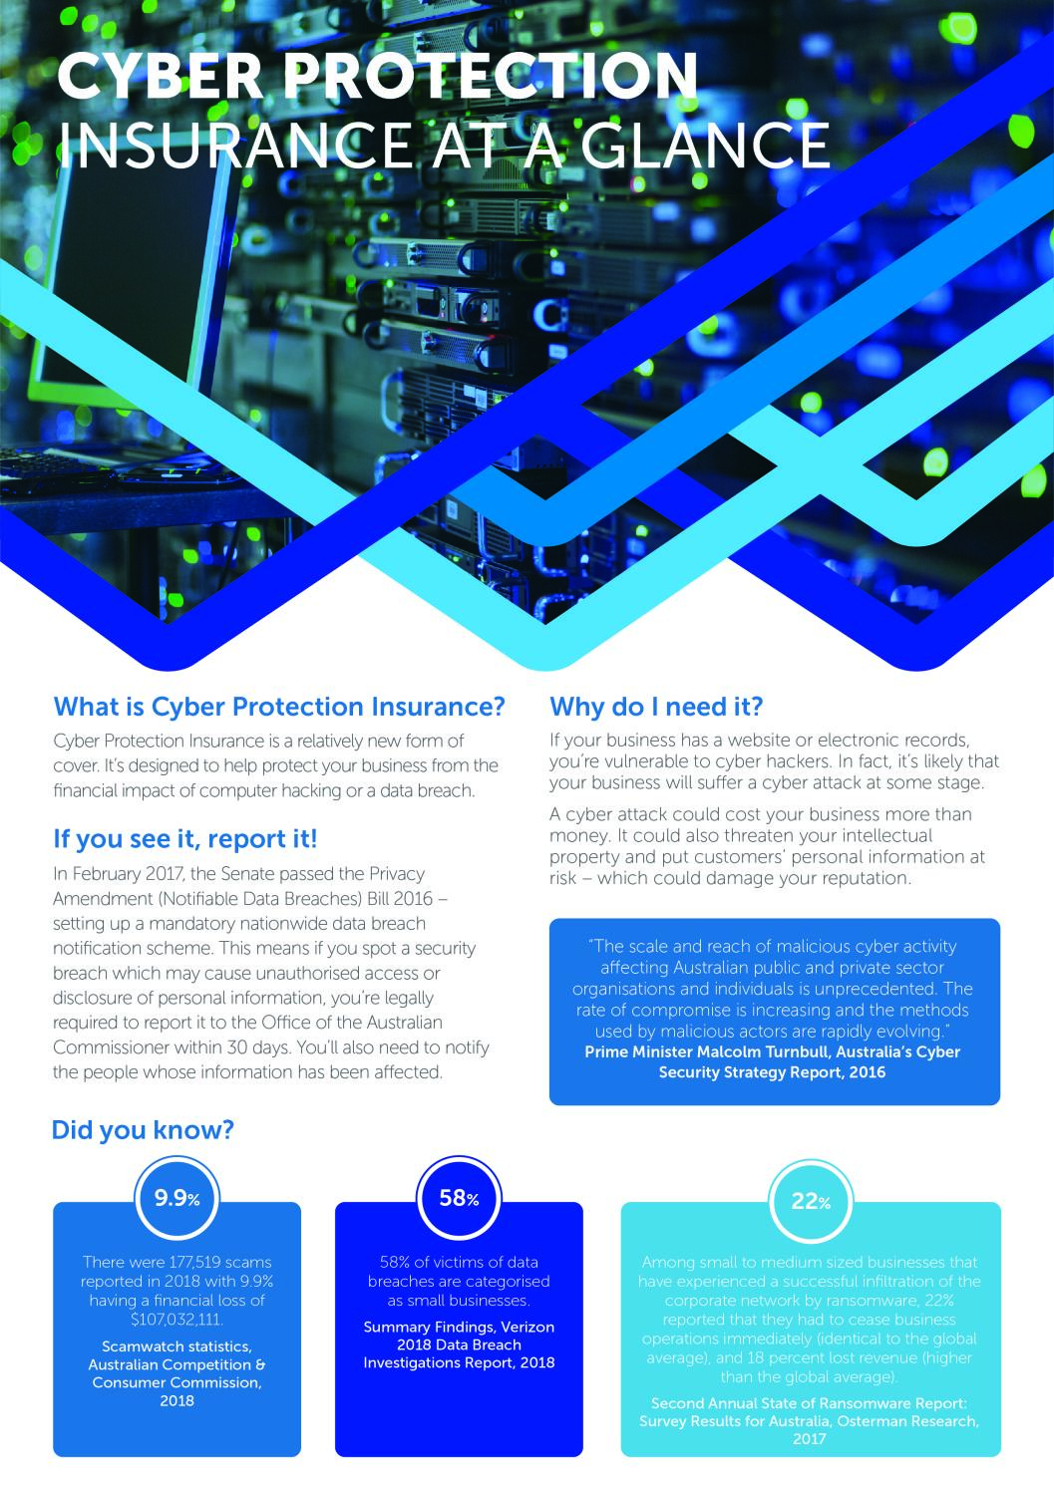

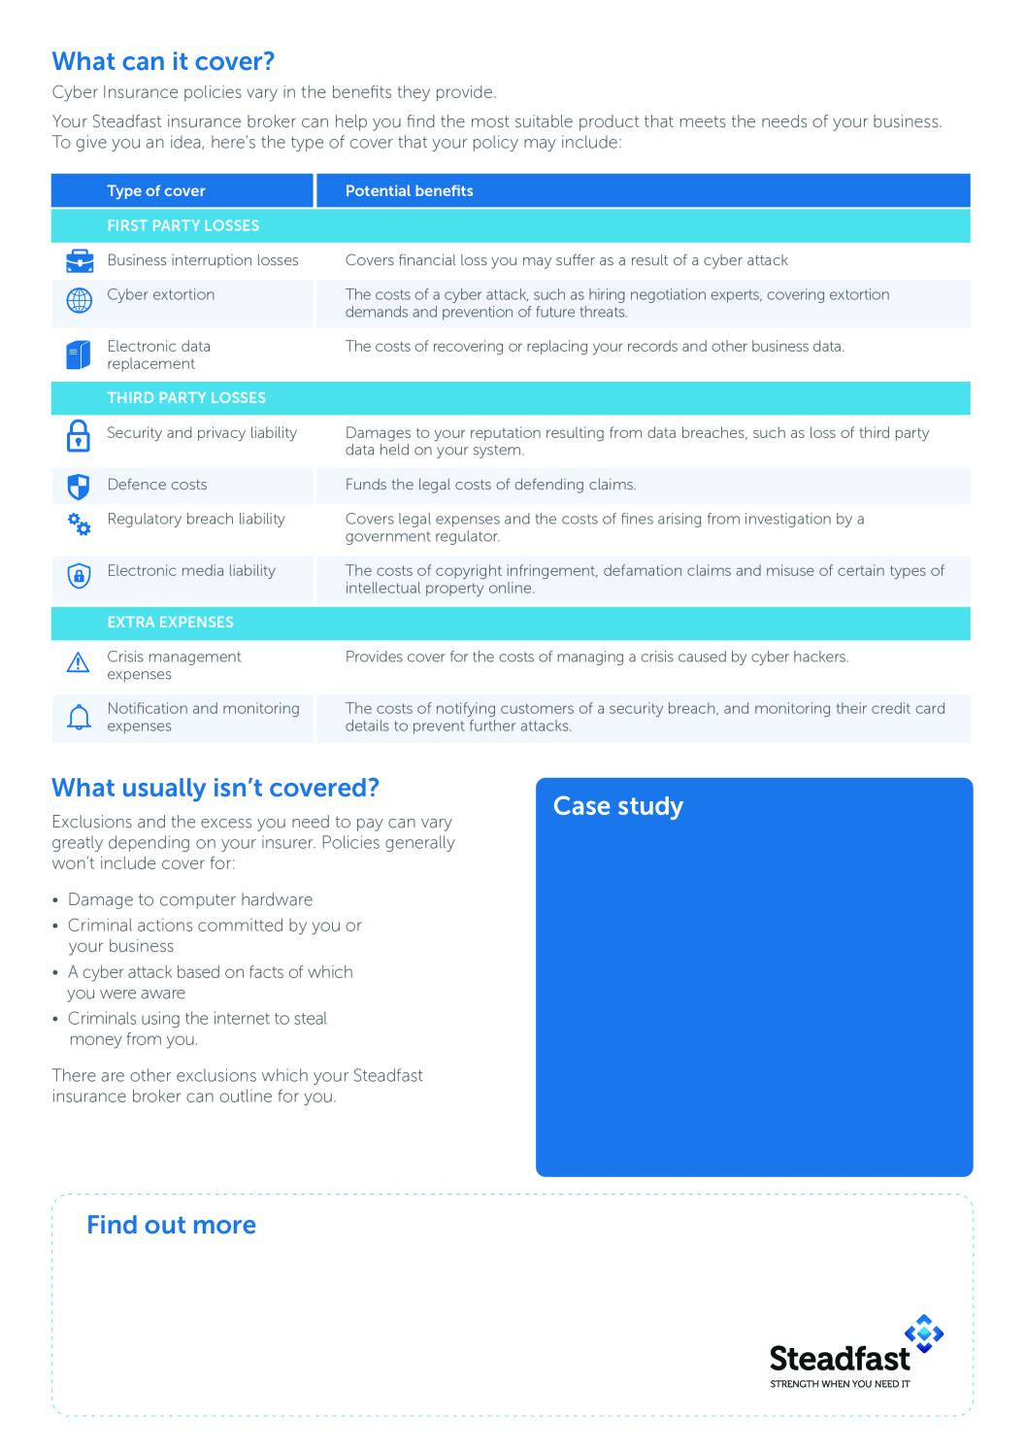

If your business involves cyber, **talk to your Steadfast insurance broker today.**

They can help you choose the right cyber insurance solution to cover you and your employees.

Your employee opens an email attachment infected with a ransomware virus. Access to your systems and data are blocked and the virus software informs you that it will remain unavailable unless you pay the ransom amount. Rather than paying the hacker and opening your business up to further extortion attempts, you hire external IT consultants to recover your back-up data and files and upgrade your antivirus software. Over the week it takes to apply these fixes, you have to close your business, causing you to lose revenue. It also affects your reputation with your clients; one of your clients threatens to sue you for the delay which cost them a large amount of money.

A Cyber Protection Insurance policy allows you to recover some of the costs you incur during this incident. Depending on your policy, you may be able to make a claim for losses caused by the interruption to your business, the costs of recovering your data and upgrading your software, and ongoing crisis management expenses.

|  |  |  |
| --- | --- | --- |
| Insert logo here | **Brokerage Name** | |
| **ABN** 00 000 000 000 | **AFSL** 000000 | |
| **P** | 00 0000 0000 |
| **E** | admin@brokerage.com.au |
| www.brokerage.com.au | |
|  | |