How to imbed the Travel Insurance link in your email or website
Visit the TravelCard Portal: https://broker.travelcard.com.au
Enter your login details. In the event you don’t have login details, please contact partnersupport@travelcard.com.au and provide them with the following:
- Network: Community Broker Network
- Business Name
- ABN
- Address
- Staff Requiring Login Details incl full name, email address and contact number.
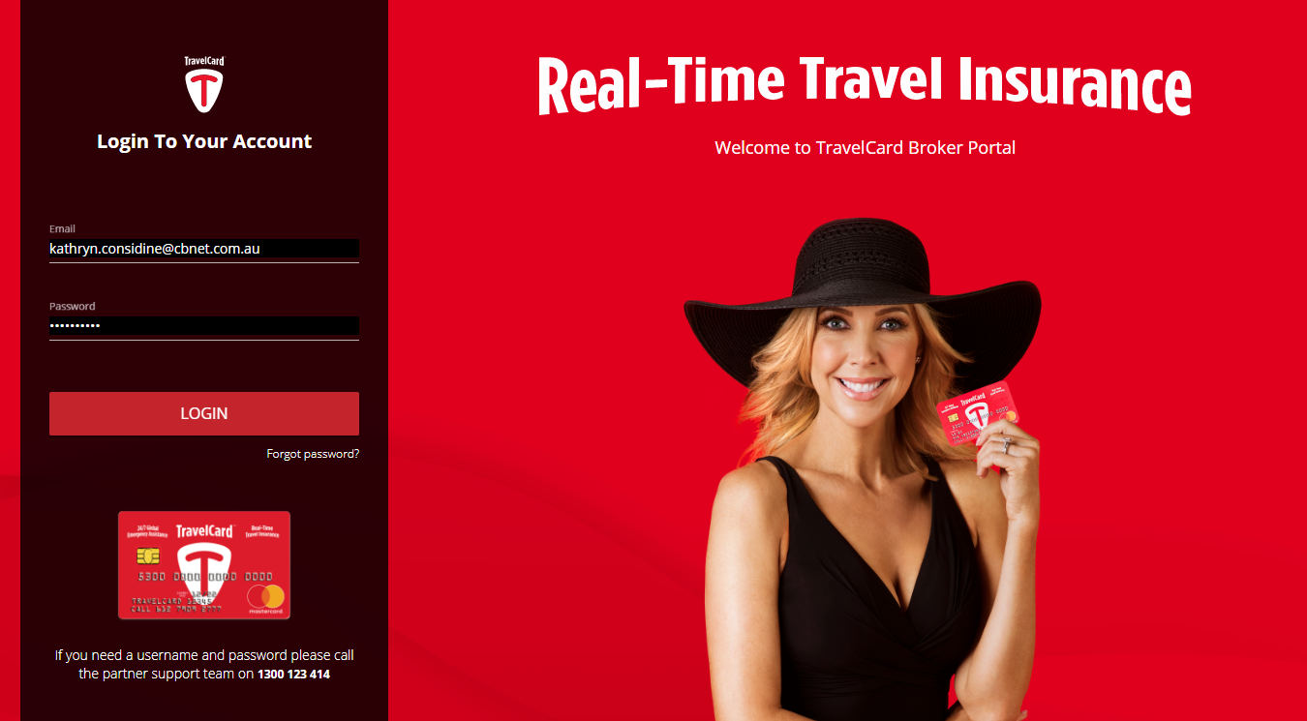
Once you are logged in, you will see a dashboard for where you can initiate quotes for your clients. Down the very bottom in the footer section of the website, you will see a link called ‘Client Connection Channel’ – see below for a zoomed snapshot.
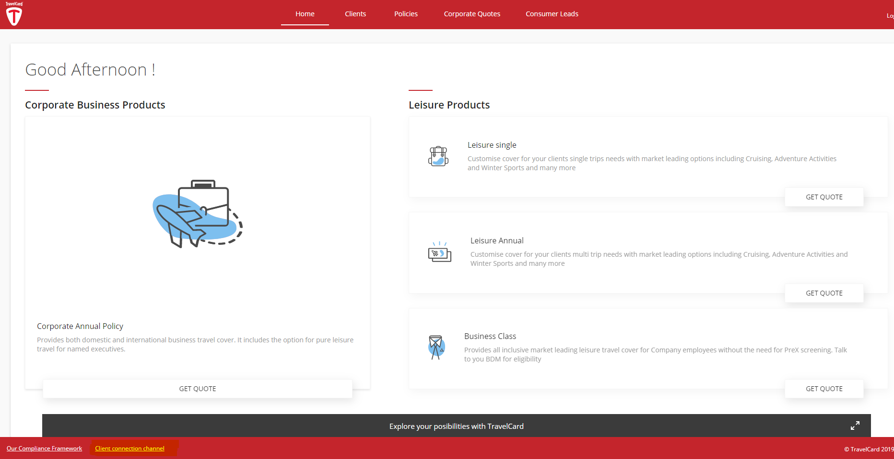
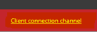
The client connection channel will give you options where you can generate marketing links and banners to promote the product to your clients and network.
To implement, please do the following:
1. For an email link, please select “link without banner” and copy the code and paste into your email signature. If you need help doing this, please contact our IT Support Team on 1300 306 852 or email them on it@cbnet.com.au
2. For a TravelCard banner for your website, choose the size of the banner that suits you. We would recommend you consult with your website administrator.

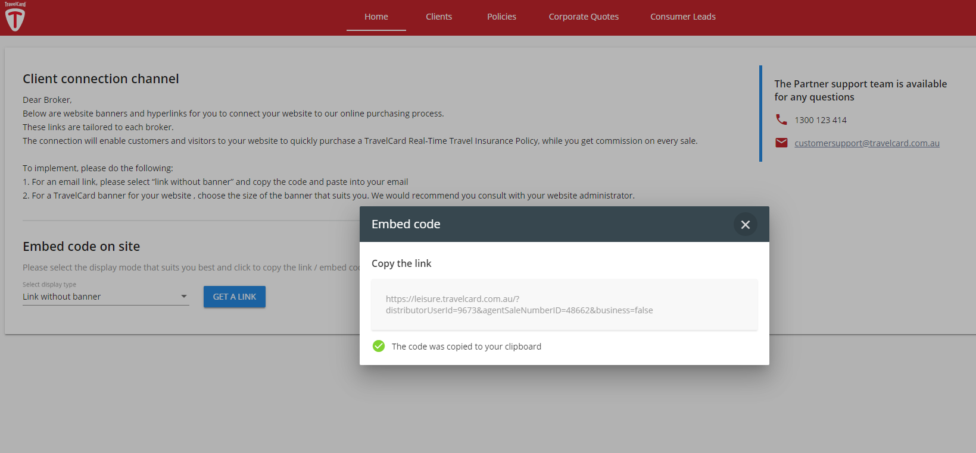

Please see size options of banners below.

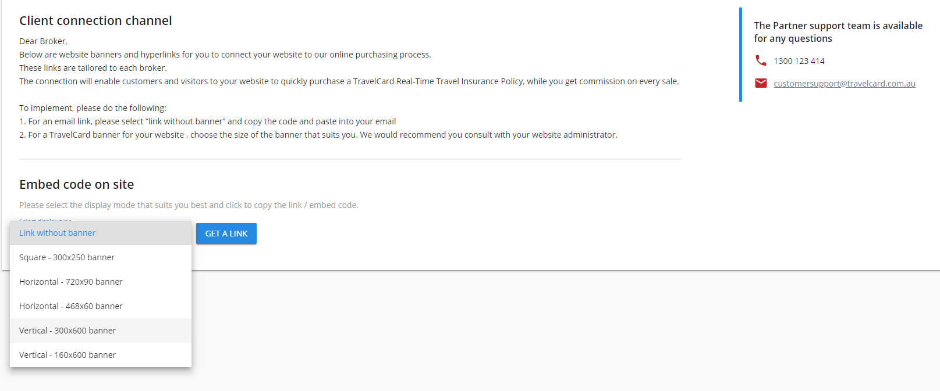

Once you select your option, click ‘Get Link’ and it will generate either a link or code for you to appropriate into your desired channel.
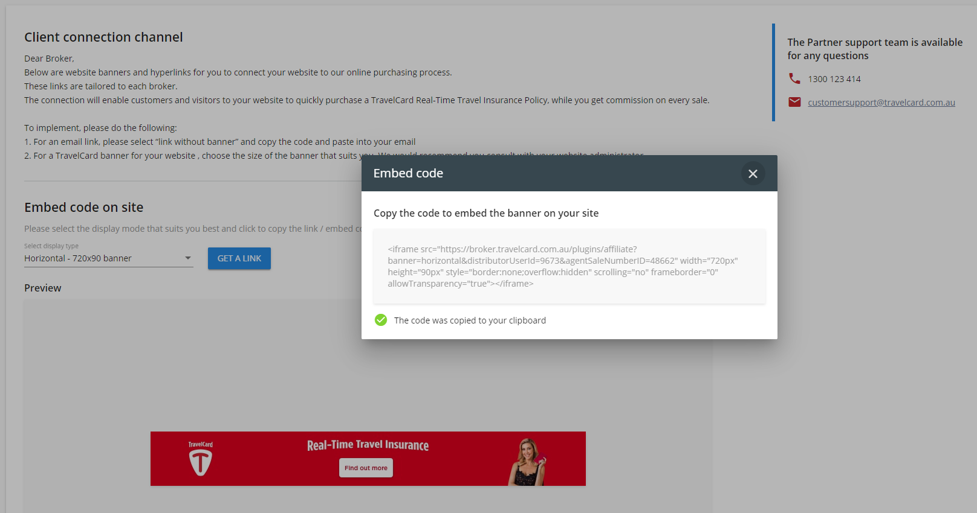
If you have any other queries about this tool, please do not hesitate to contact the Network Advisor Team (NAT) on 1300 905 577 (Option 1).

