CBN pride ourselves on empowering our network, and supporting the community. With this, comes the notion of being there for one another. Accordingly, CBN are proud to announce a “kindness collaboration” with not-for-profit organisation, Kindsum.

CBN – Kindsum Community Project
Kindsum is an online platform which plays matchmaker for acts of non-financial kindness. It connects those who deserve help with those who are willing to help.
We’re calling this the CBN-Kindsum Community Project.
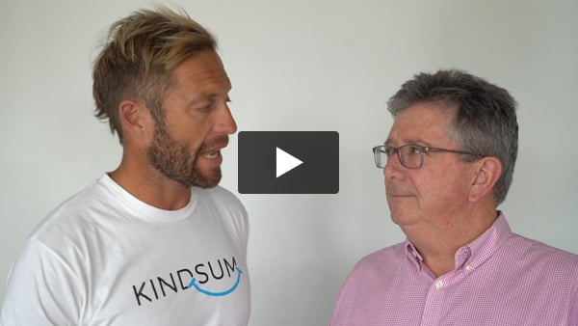
Click here to nominate

Empowering you to choose who you want to help
CBN are searching for someone within your networks who genuinely deserves an act of kindness.
Once we find that person or group, we’ll provide hands on support, so together, we can make a difference, simply by being kind!

What you need to do

Step 1: Nominate now
CBN are asking YOU to nominate someone in your personal or professional network who deserves some love and support!
It could be help for an individual struggling to tackle a hurdle alone or creating an experience to show a deserving family someone is thinking of them.
For some kindness inspiration, click here.
Nominations close: Saturday 29th of February 2020.
Nominate someone who needs kindness
Step 2: Kindness recipient announced & call for volunteers
Once all nominations are in, a kindness project will be selected and shared with you.
At this point we will be looking for volunteers to get involved and make a lasting difference to the lives of others.
Join us in making something special happen by nominating now.

